**Title:** Innovative Plastic Waste Management: Utilization in Road Construction and Sustainable Applications

**Md. Sadat Bin Shahid**

The methodology for innovative plastic waste management involves a series of systematic steps to ensure eco-friendly and sustainable utilization in road construction and other applications. The process begins with the collection and segregation of plastic waste from various sources, followed by washing, shredding, and quality control to prepare the material for reuse. Shredded plastic is then used to develop plastic-modified bitumen (PMB) or as partial replacements for natural aggregates in concrete and asphalt. In road construction, PMB enhances pavement durability and flexibility, while sustainable applications include creating building materials, 3D printing products, and green packaging solutions. Environmental and economic assessments, such as life cycle analysis and cost-benefit evaluations, ensure the viability of these approaches. Community engagement, workshops, and policy advocacy further promote awareness and adoption, while research and development explore new technologies to scale operations and foster innovation. This comprehensive methodology integrates scientific, economic, and social elements to address plastic waste challenges effectively.









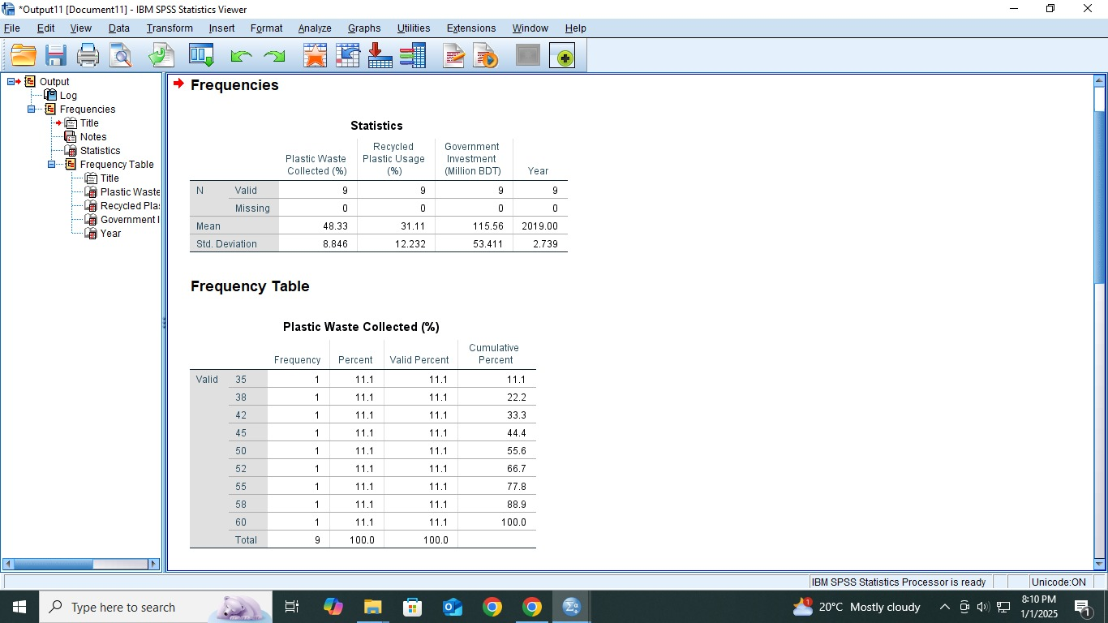

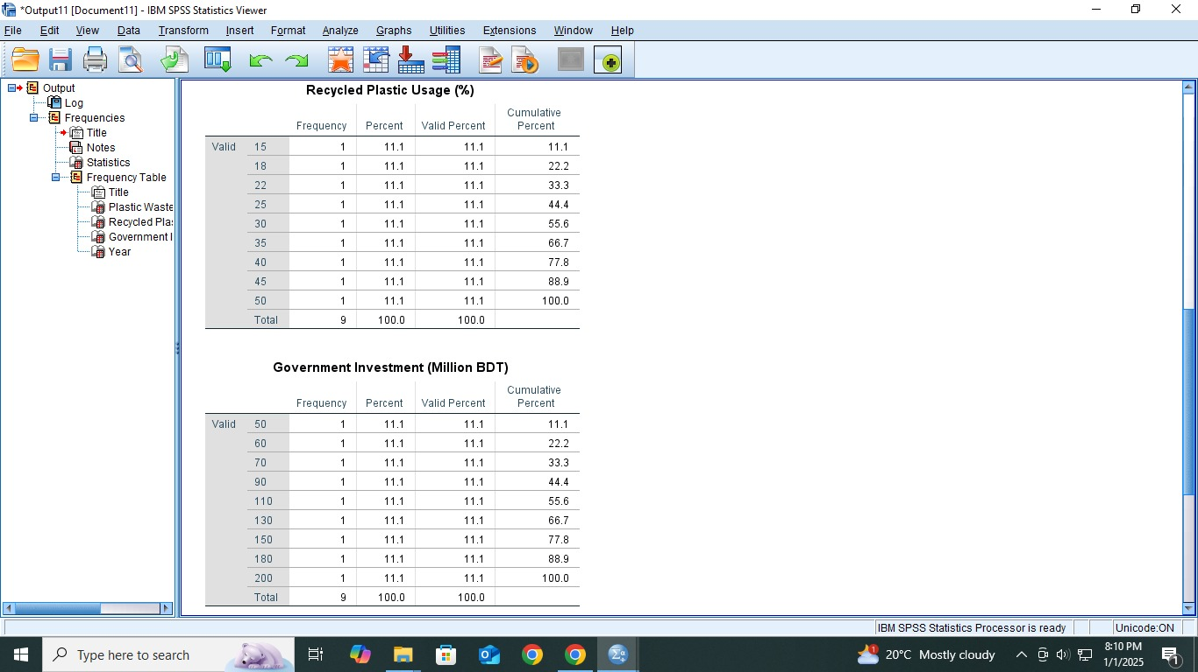









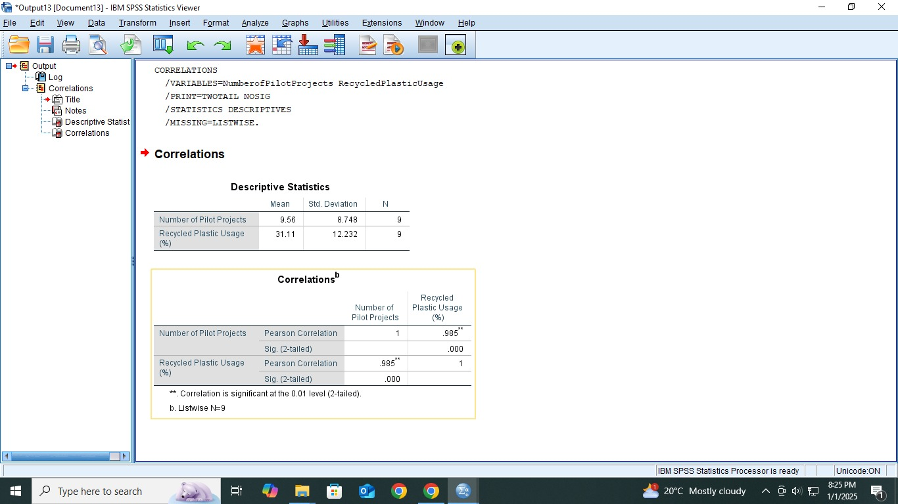

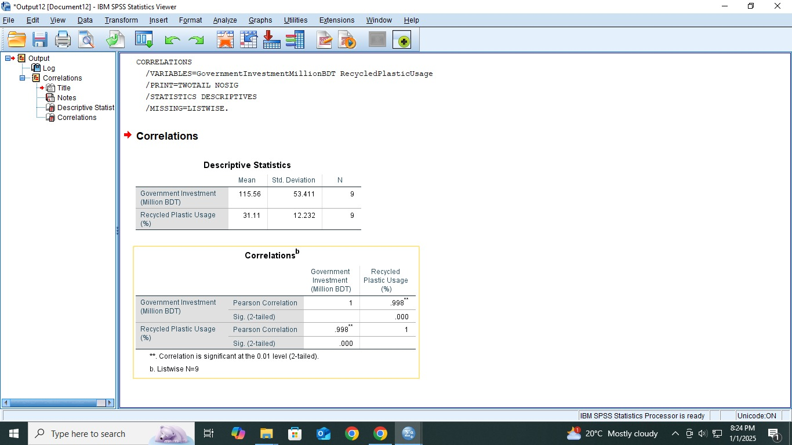



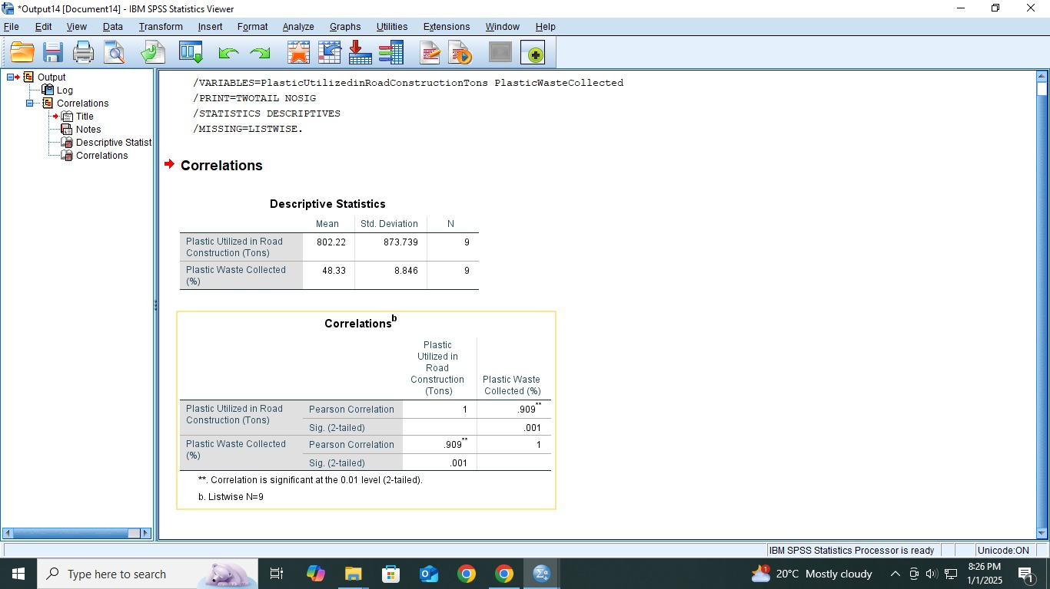



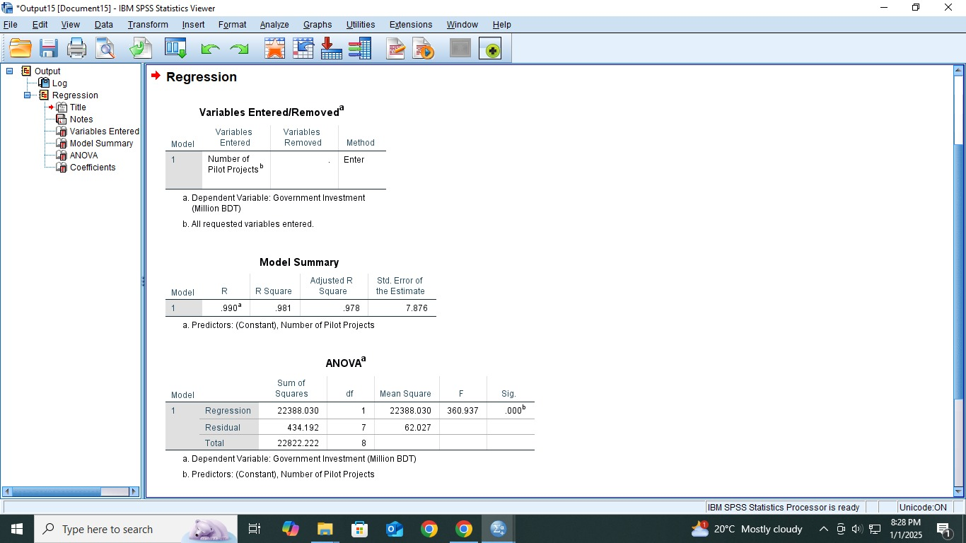

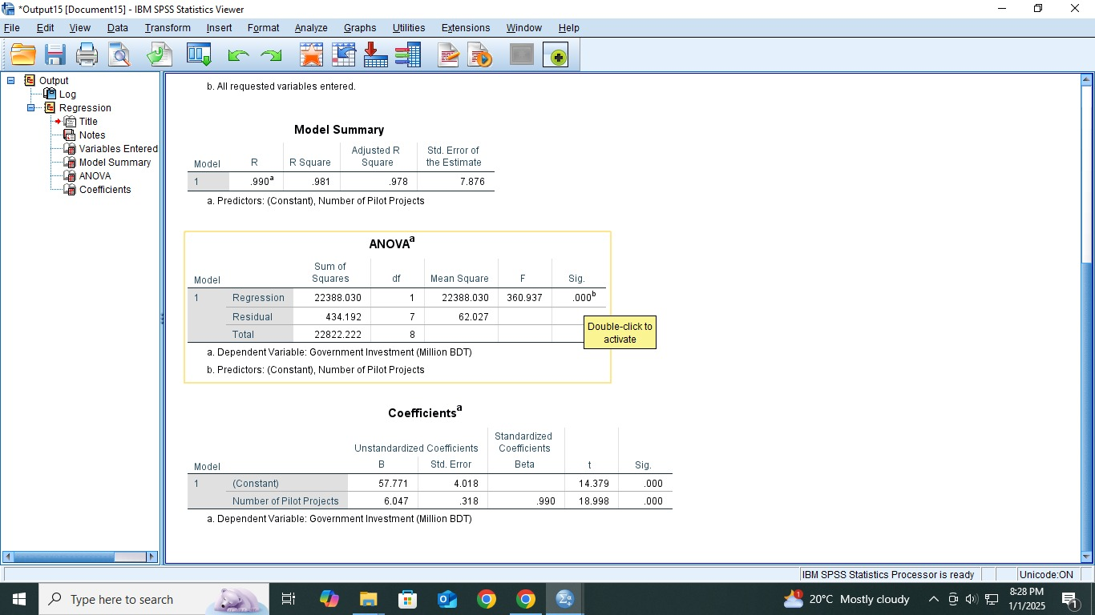

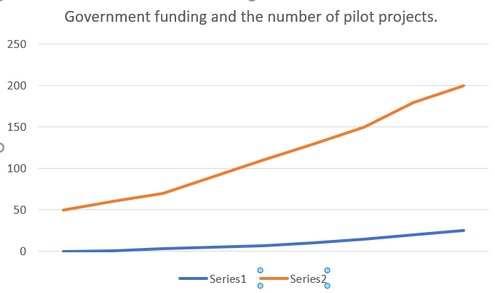

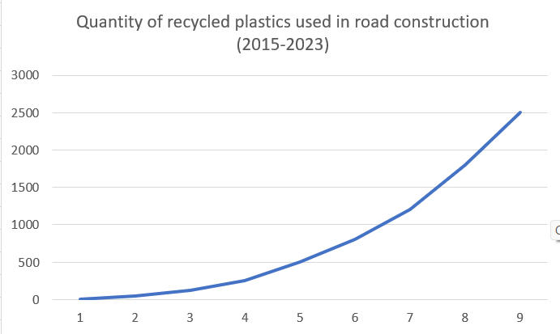

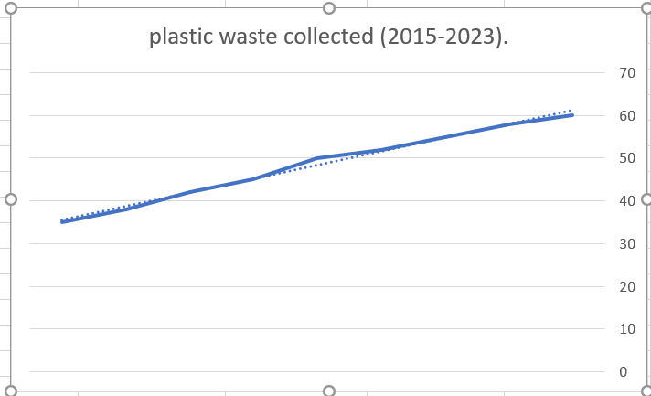

**Results**

The study highlighted significant progress in plastic waste management from 2015 to 2023. Plastic waste collection increased from 35% to 60%, while recycled plastics in road construction grew from zero to 2,500 tons. Government funding quadrupled from 50 million BDT to 200 million BDT, and pilot projects rose from zero to 25. Roads using plastic-modified asphalt proved more durable, cost-effective, and water-resistant than conventional roads. Recycled plastic usage in diverse applications increased by 50%, with promising advancements in composite materials, construction blocks, and pyrolysis fuels.

### Conclusion

Innovative plastic waste management shows immense potential in addressing environmental challenges and supporting sustainable development. Enhanced collection, recycling, and integration of plastics into infrastructure demonstrate feasibility and effectiveness. To expand these initiatives, greater investment, public-private partnerships, and supportive policies are essential. Community participation and technological advancements remain key to achieving a sustainable future.